Unit 2 Northwind Front-End Screenshots and repository link

Corey Crooks
Purdue University Global
IT481 – Advanced Software Development
Ahmad Kassem
May 3rd, 2023

Program at startup:
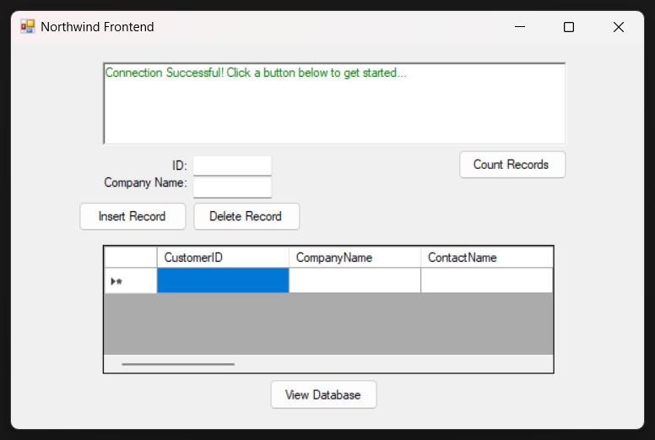

Program when counting records:
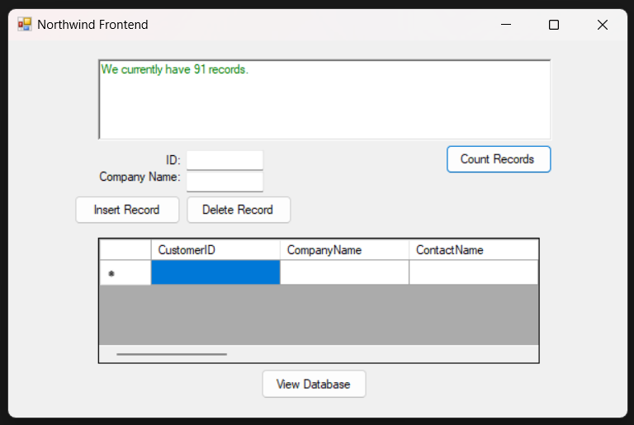

Program when inserting a record:
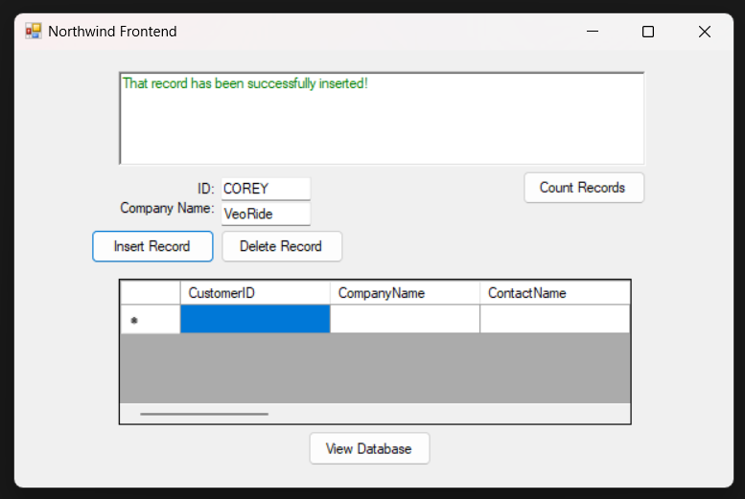

Program when viewing the database (showing record insertion):
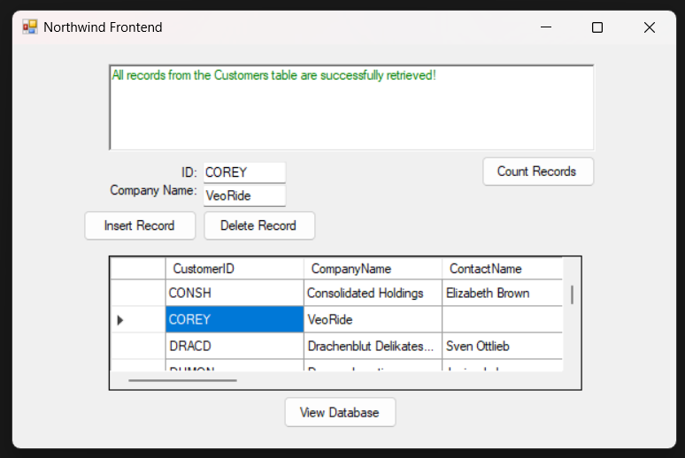

Program when deleting a record:
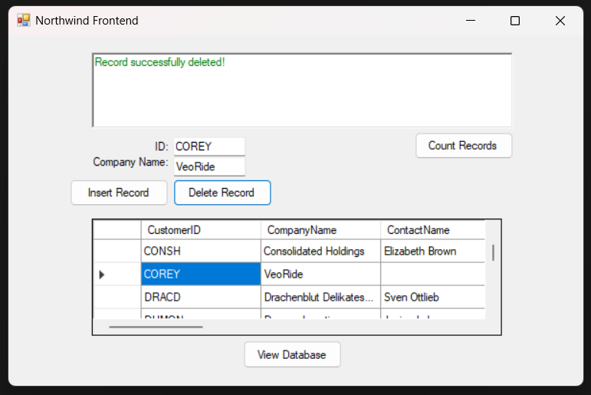

Program when viewing the database (showing record insertion):
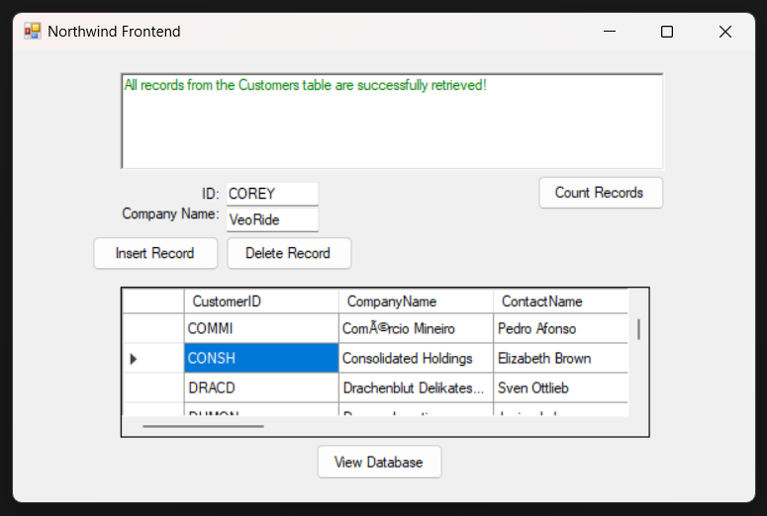

Screenshot proof of upload to SCM (GitHub):
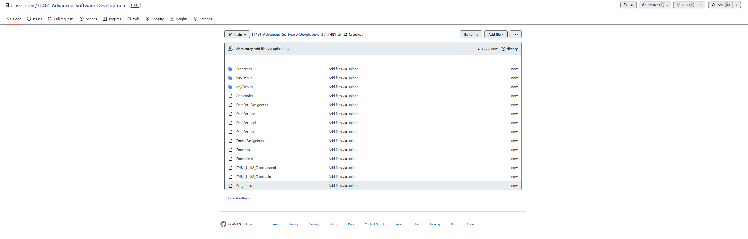
URL:
https://github.com/classicorey/IT481-Advanced-Software-Development/tree/main/IT481_Unit2_Crooks

